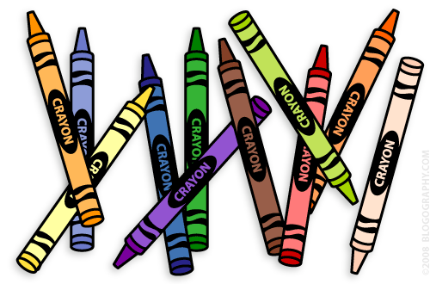
Our 1st Grade
The Week of Dec. 12th – 16th
Classroom News

Email: Lweeks@bluevalleyk12.org
Website: www.bluevalleyk12.org/hes/lweeks

This homework will be due on Dec. 16th and then they won’t have another homework assignment until the week of January 9th. Over break I want your families to enjoy one another without having to worry about homework. The only thing that students should continue to do is to READ! If you want your child to be doing more, take a look at past homework challenges on my website (under newsletters) and have your child complete ones they haven’t done.

Important Info
Upcoming Events
Tech of the Week
Website of the Week: There is a website to practice MAP skills for math and reading. Click on the score that your child received and there are great activities they can do to practice for it! We won’t be taking the tests again until the spring but great if you have any extra time at home.
Math - http://www.sowashco.org/ro//pages/studentlinks/map/
Reading - http://www.sowashco.org/ro/pages/studentlinks/map/reading.htm
App of the Week: Glow Draw is a fun app that your child can use to practice spelling words and other words that have the spelling pattern in it! This app is free!

Math Challenge of the Week: I have been slowly introducing some multiplication strategies with the students as we are learning about patterns. For example, they know that 5+5+5+5 (skip counting by 5's) equals 20. I have been teaching them how to make that into a multiplication problem (5x4=20). Have your child turn some (at least 4 problems) addition problems into multiplication problems. Here are some examples (2+2+2+2=8 and 2x4=8 / 4+4+4=12 and 4x3=12). IF YOUR CHILD IS NOT READY FOR THIS, CHOOSE A DIFFERENT CHALLENGE OF THE WEEK!
Reading Challenge of the Week: We have been doing a few author’s studies during read aloud time recently. We compare and contrast books that the same author writes. Have your child read 2 different books by the same author. Then have them compare and contrast those books. What are alike? What is different?
Writing Challenge of the Week: We have been discussing the virtues quite a bit recently. Have your child pick one of the virtues and write about a time that they showed that virtue! The virtues are respect, gratitude, honesty, responsibility, patience, resiliency, compassion, courage, self-discipline, and perseverance.

Challenges of the Week

Dec. 20th 1/2 Day of School
Winter Party @ 11:00am
Dec. 21 – Jan. 3 No School
Jan. 4th Reading logs are due

